



LAB MANUAL
DBMS

Disclaimer: The content is curated from online/offline resources and used for educational purpose only
Swapping Two Numbers Using Bitwise XOR

Objective:
To implement a function in Python that swaps two numbers without using a third variable, using the bitwise XOR operator.

Problem Statement:
Write a Python function to swap two numbers using the XOR (^) operator without using any third or temporary variable.

Equipment Required:
- A computer with:
  - Python 3.x installed
  - Jupyter Notebook (Anaconda or via pip install)
- Any code editor (optional)
- Internet (for further references)

Prerequisites:
- Basic Python programming skills
- Understanding of variables and bitwise operators
- Familiarity with binary number representation and XOR logic

Procedure:
Step 1: Initialize Two Variables

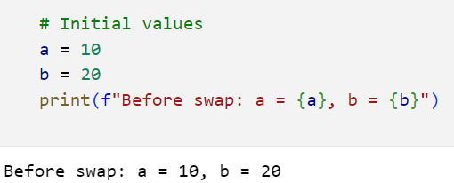

Step 2: Swap Using XOR Operator

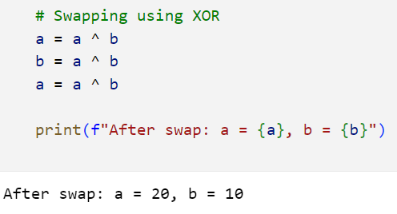

Step 3: Wrap It in a Function

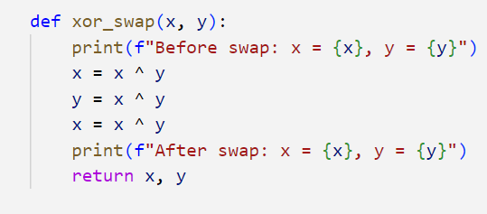

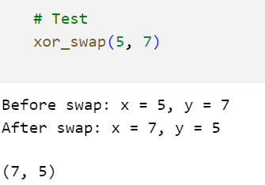

Conclusion
In this lab, we demonstrated how to use the XOR bitwise operator to swap two integers without using a third variable.
XOR is reversible. Each bit in the binary representation of the numbers is flipped in a way that allows us to retrieve the original values in reverse order.
This technique is memory efficient and useful in environments where using an extra variable is not preferred.

